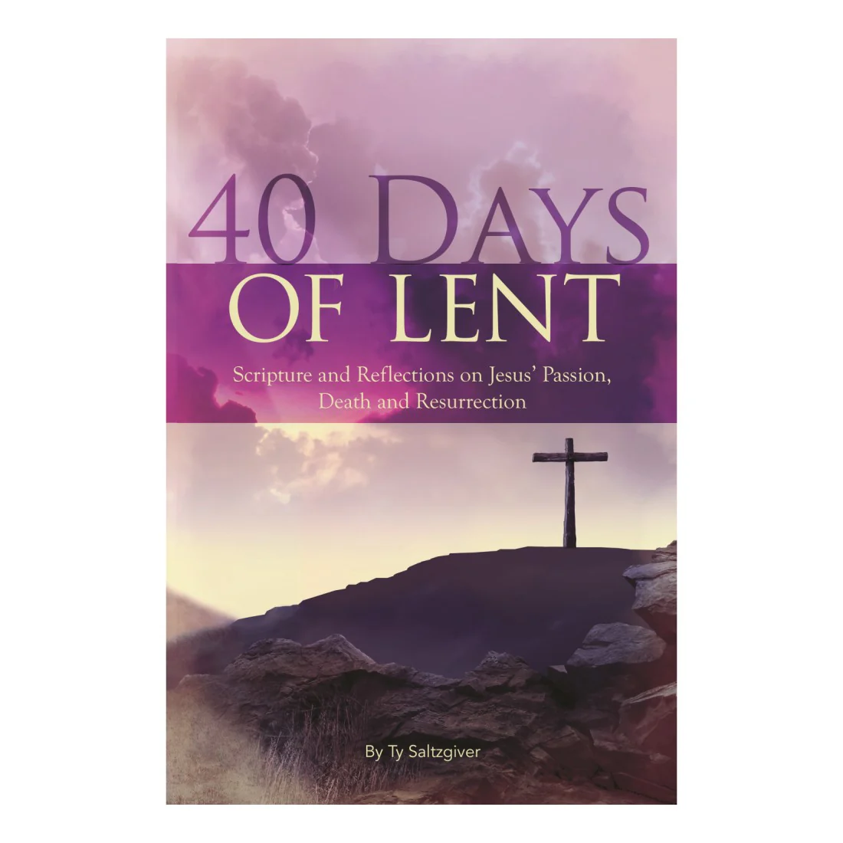

Wed, Feb 18, 2026 – Thu, Apr 2, 2026

What Is Lent?
1. Lent is a Season of Preparation
Lent is the 40-day journey leading up to Resurrection Sunday.
It mirrors Jesus’ 40 days in the wilderness.
It’s a time to slow down, reflect, and draw closer to God.

2. Lent Is About the Heart, Not Just Habits
It’s not just about “giving something up.”
It’s about making room for more of God.
It’s about repentance, renewal, and realignment.

3. It’s a Personal Invitation, NOT a Requirement
Participation is voluntary.
This is not about pressure — it’s about pursuit.
If you feel led, lean in.

What Makes Lent Spiritually Meaningful?
4. It Creates Intentional Space for God
Fasting, praying, reflecting — these help quiet distractions.
When we remove something, we replace it with time with God.

5. It Strengthens Spiritual Discipline
Small daily commitments build spiritual maturity.
It helps us become more aware of our dependence on Him.

6. It Prepares Our Hearts for Resurrection Power
We don’t rush to Easter.
We walk through surrender before we celebrate victory.

Small Ways We Can Participate
- Give up one distraction (social media, sweets, unnecessary spending).
- Add 10–15 minutes of daily prayer or scripture reading.
- Fast one meal a week and use that time to pray.
- Practice daily gratitude.
- Serve someone intentionally each week.
- Read through one Gospel during the 40 days.

“It doesn’t have to be big to be meaningful. Small faithfulness brings deep transformation.”

My 40 Day Commitment to LENT
I, ______________________________________ (insert name), commit to 40 Days of Fasting & Prayer for LENT Season with my ONE Church Family.
On this day February ____, I commit to begin a full 40 day Journey to this type of Fasting ____________________________________ through Thursday April 2nd, 2026.
(Insert Selected Type of Fast)

On today, I commit to Fast From: ________________________________________________________________________________________________________________________________________________
(List What You Will Be Specifically Fasting From)

After my 40 day Lent Season is Up, my Declaration of Faithfulness to God will be: (Daniel 1:8-17)
__________________________________________________________________

I commit to dedicate my time to God, to thoughtful prayer and meditation. I commit to read my word (The Bible). I commit to spend alone time with God and to do my best to journal daily or weekly my progress between God and Myself.
I begin today by asking God for help to complete My 40 Day Commitment and I solicit this prayer for the process:
Dear Lord,
________________________________________________________________________________________________________________________________________________________________________________________________________________________________________________________________________________________________________________________________________________________________________________________________________________________________________________________________________________________________________________________________________________________________________________________________________________________________________________________________________

Sincerely; ______________________________________ Dated: ___________________
YOUTH FORM
My 40 Day Commitment to LENT
I, ______________________________________ (insert name), commit to 40 Days of Fasting & Prayer for LENT Season with my ONE Church Family.
On this day February ____, I commit to begin a full 40 day Journey to this type of Fasting ______________________________________ through Thursday April 2nd, 2026.

Beginning Today, I commit to Fast from: ________________________________________________________________________________________________________________________________________________
________________________________________________________________________________________________________________________________________________
(List What You Will Be Specifically Fasting From. I.E. Video Games, Tik Tok, Social Media, Phone, etc.)

After 40 days of Lent, my Declaration of Faithfulness to God will be: (Daniel 1:8-17)
________________________________________________________________________

I commit to dedicate my time to God, to thoughtful prayer and meditation. I commit to read my word (The Bible). I commit to do my best to journal daily or weekly my progress between God and Myself.
I begin today by asking God for help to complete My 40 Day Commitment and I solicit this prayer for the process:
Dear Lord,
________________________________________________________________________________________________________________________________________________________________________________________________________________________________________________________________________________________________________________________________________________________________________________________________________________________________________________
Sincerely; ______________________________________ Dated: ___________________

